JAVA ELECTRIC BILL LAB REPORT

Name and Student ID: Jibran Akhter - 1073973
Date project completed: 3/16/2024
Platform (Mac, PC, Linux, etc.): Windows 11 PC
Development system (onlineGDB, NetBeans, Eclipse): onlineGDB
Enter the kWh: 1500

Tier1 charges $80.50
Tier2 charges $319.00
Tier3 charges $22.50
Energy Tax $0.20
Total bill $422.20

OBJECTIVES
Analyze a project definition
Convert the project description into code without a sample program
Separate kilo Watt hours into tiers using if...else if...else statements
Handle non-numeric inputs using try...throw...catch

PROJECT DESCRIPTION
Create a program that does the following:
- Use CONSTANTS to define the kwh limits and billing rate for each tier
- Read the number of kWh used by the customer
- The Energy Tax of 0.20 is just added to the total bill, not used as a tax rate and multiplied by the total bill.
- Compute the Electric Bill with a lower rate for the baseline kWh and a higher rate for kWh over the baseline
- Display:
  - The kWh used for each tier and the dollar and cents amount of the bill for each tier with two digits past the decimal
  - The Energy Commission tax with two digits past the decimal
  - The total bill that includes the amount for each tier and the Energy Commission with two digits past the decimal

Use constants to define limits and billing for each tier
 | Tier1 | Tier2 | Tier3
Tier limit | 350 | 1450
Bill rate per kWh | 0.23 | 0.29 | 0.45

INPUT – PROCESS – OUTPUT TABLE
INPUT | PROCESSING  Your program must use constants instead of numeric values for kWh limits and billing rates for each tier. | OUTPUTS
kWh | Input kWh from user as a double  Determine Tier1_kWh(up to 350)  Determine Tier2_kWh (up to 1450)  Determine Tier3_kWh (over 1450)  Tier1_Bill = Tier1_kWh * 0.23  Tier2_Bill = Tier1_kWh * 0.29  Tier3_Bill = Tier1_kWh * 0.45  Electric_Bill = Tier1_Bill + Tier2_Bill + Tier3_Bill + Commission_Tax  Display Electric_Bill | charges for each tier  energy tax  total bill

TEST DATA TABLE
Fill in the Test Data Values and Expected Results as shown on the lab assignment from Canvas.
Fill in the Actual Results after you have run and tested your program
TEST DATA VALUES  kwh | EXPECTED RESULT  Computed values before the program is run | ACTUAL RESULT  Fill in the output displayed  by the program
300 | $69.00 | 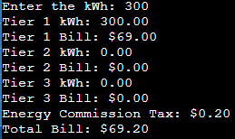
500 | $124.20 | 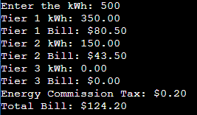
1500 | $422.20 | 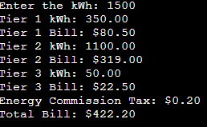
six hundred | illegal | 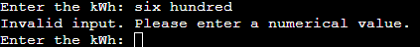

Sample program execution
kWh used | Tier1 bill | Tier2 bill | Tier3 bill | Energy  Commission Tax | TOTAL
300 | 69.00 | 0.00 | 0.00 | 0.20 | 69.20
500 | 80.50 | 43.50 | 0.00 | 0.20 | 124.20
1500 | 80.50 | 319.00 | 22.50 | 0.20 | 422.20

DISCUSSION
What did you do to develop the program? ("Followed the Directions" is not a complete description)

I sat down and thought about how people usually calculate their electric bills, breaking down the process step by step. Then, I wrote the Java code to mirror that process, making sure to handle potential mistakes gracefully, like if someone enters something other than a number when asked for kWh usage. After writing the code, I tested it with different scenarios to ensure it works smoothly, just like how you'd want your own electric bill calculations to go without any surprises.

What problems did you have and how did you overcome the problems?

A challenge was to determine the correct billing rates and tier limits to accurately calculate the electric bill. To overcome this, I carefully reviewed the requirements and specifications provided, ensuring that the code accurately reflected the defined billing tiers and rates.

I encountered minor issues with formatting and rounding errors when calculating the billing amounts. I resolved these by using appropriate formatting techniques and rounding methods to ensure precision in the calculations and accurate display of the results.

SCREENSHOTS
Paste four screenshots on the next page.

Capture only the portion of the screen that shows the calculator or program output. Do not capture the entire screen even though it may also contain the program output. If I need to zoom in on a screenshot, sometimes the image resolution is so poor that I am not able to read it. If this happens, I will ask that you resubmit your lab report. Refer to these instructions capturing screenshots and pasting them to the lab report.

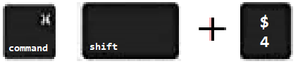
For the Mac
- hold down command + shift keys and press the 4 key
to get a screenshot of a selected area of the screen
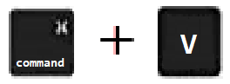
- Use the mouse or touchpad to select the desired area of the screen you want to save
- use command+V to paste into the lab report

For Windows

- use Microsoft's Snipping Tool by holding down the
Windows and Shift keys and tapping the ‘S’ key
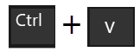
- Use the mouse or keypad to select the part of the screen you want to save
- use Ctrl+V to into the lab report

Paste four screenshots here
Screenshot #1 – When kWh = 300

Screenshot #2 – When kWh = 500

Screenshot #3 – When kWh = 1500

Screenshot #4 – When letters are entered for kWh instead of numbers

